GGN - Geopark Annual Report 2018
GGN Geopark Annual Report should be two pages
1. GEOPARK IDENTITY
Geopark name, country, regional Network: Hexigten UNESCO Global Geopark (China, APGN)
Year of inscription / Year of the last revalidation: 2005/2017
Representative Photo (from the most important event this year)
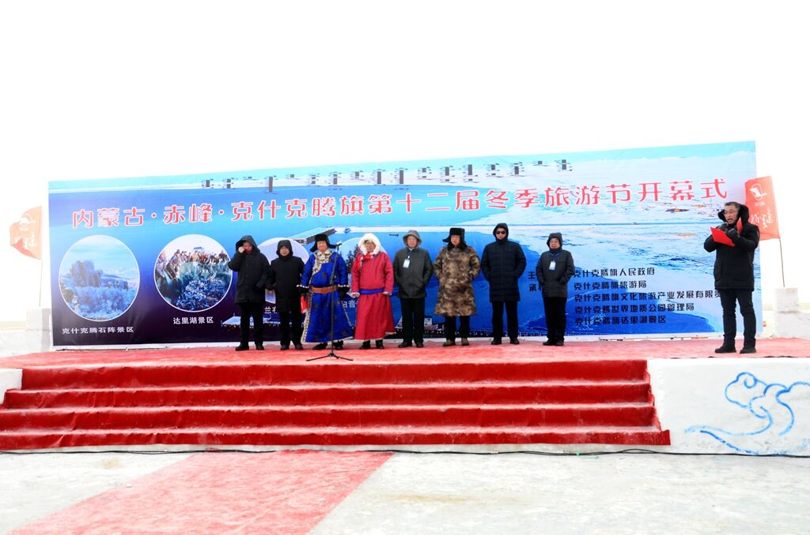
The 12th Winter Tourism Festival of Hexigten
2. GEOPARK FIGURES
Number of Geopark staffs: 162 staffs including 7 geoscientists, 5 employee.
Number of Visitors: 6 million
Number of Geopark events: 7
The 12th Winter Tourism Festival of Hexigten;Activities on the 49th World Earth Day;Sciencen popularization in campus--Donating Books;Little tour guide training; Sciencen popularization in community--Science lecture & Visiting Museum;Tree Planting Activity in Baiyinbao;Building a sitser park with Mohe National Geopark.
Number school classes realize Geopark educational programmes: 30
Number of Geopark press release: 18
3. GEOPARK ACTIVITIES (bulletize)
Major achivements in 2018
Cooperated with the experts team to carry out related research work: completed the “research on the cause and evolution of Dali Lake”,”the route of scientific exploration of Xar Moron River”, and “the analysis and arrangement of field observation data of Hexigten UGGp”, “Compilation of data on sandstorm monitoring data in Hexigten UGGp", and " Collection of the Meteorological Monitoring Data of the Hexigten UGGp"; The project team of "Hexigten Guhu Xiang Deposition Record of the Late Pleistocene Climate Change “ carry by China University of Geosciences (Beijing) conducted a one-week survey of wild geological heritage in the park.
Contribution towards GGN - Networking and Participation
Take part in the 8th International Conference on UNESCO Global Geoparks; International Course on Geoparks Management and Development, Beijing 2018;Annual meeting for UNESCO Global Geoparks in China-2018;
Management and Financial status
Administration for Hexigten UNESCO Global Geopark has 5 departments and 20 staffs, with well financial situation. The tourism revenue in 2018 is 6.3 billion RMB.
Geoconservation
Strictly in accordance with the provisions of the Kashkent World Geopark Planning and Geological Relics Protection Regulations, it is forbidden to carry out industrial and mining activities in the geological heritage protection area; regularly inspect, update and maintain road signs, geological relics interpretation cards, etc.; Specimens are collected from the geological heritage reserve.
Sustainable tourism (Geotourism)
There are 11 star-ranked hotels, 140 restaurants, 13 travel agencies, 120 guides, 165 sales and selling stalls, more than 200 agritainments, and the staff number in total engaged in tourism-related enterprises reached as high as 30,000 .
New Education programmes on geoconservation, sustainable development and disaster risk reduction
Make plans for the geoheritage protection and science popularization of 2018. Hold on some activities on International Day for Disaster Risk Reduction.
Strategic Partnership
Multi-field cooperation: signing cooperation agreements with China University of Geosciences (Beijing) Museum; establishing partnerships with designated hotels, agritainments, and reception centers; conducting long-term cooperation with Lanhuatong Language Training School and Wu Yongjuan Art Training Center.
Promotional activities
18 fixed outdoor billboards are placed all year round in main visitor source cities; A variety of geopark advertisements and special reports have been shown on some city TV; Post articles in some travel magazin;Promote at local TV stations, etc.
4. Contacts:
Manager: Hanmin Zhang hexigtengeopark@163.com Geologist: Mingzhong Tian

